Andrew Camps

Derek Paris

November 14, 2017

ECE 478/578 Project #2

**2.1: AS Classification**

**Description**: A pie chart that shows the (%) distribution of ASes to the three classes (Transit/Access, Content, Enterprise).

|  |  |
| --- | --- |
| **Graph 1: AS Class Distribution** | |
| Transit/Access | 42.17% |
| Enterprise | 53.29% |
| Content | 4.54% |

**Explanation:** This pie chart has a total number of ASes of over 50,000. It is shown in the graph that a majority of the ASes fall into the category of enterprise or transit/access class. Over 50% of the nodes are stub nodes which create traffic and pass this traffic to other node types.

**2.2: Topology Inference Through AS Links**

**Description:** A histogram of the AS node degree distribution.

|  |  |
| --- | --- |
| **Graph 2: AS Node Degree Distribution** | |
| 1 | 20913 |
| 2 - 5 | 29450 |
| 6 - 100 | 7413 |
| 101 - 200 | 136 |
| 201 - 1000 | 812 |
| 1000+ | 89 |

**Explanation:** From the graph, it is clear that a majority of the ASes on the internet have a very small amount of connections to other nodes. They have in the range of at most 1 – 100 edges that will connect to other ASes. These ASes with very small degrees most likely seen all of their traffic to ASes of larger degree. The small amount of ASes that have many connections are in the range of 100 – 1000+. The ASes with many connections in the 1000+ range are most likely top ranked nodes that handle much of the traffic from the lower degree ASes and form the backbone of the internet.

**Description:** A histogram of the IP space assigned to each AS. IP space has assigned to each AS has been normalized to the total IP space

|  |  |
| --- | --- |
| **Graph 3: AS IP Space Distribution** | |
| 2^0-2^6 | 24 |
| 2^6-2^10 | 22127 |
| 2^10-2^14 | 29000 |
| 2^14-2^18 | 7007 |
| 2^18-2^22 | 982 |
| 2^22-2^26 | 154 |
| 2^26-2^32 | 7 |

**Explanation:** From the graph, a majority of the ASes have an IP distribution in the range of

26 – 218. This means that the majority of ASes of a number of unique IP address anywhere from 64 – 260,000. Using the high end of that range this would be less than 0.01% of the total IP space. There are very few nodes that have an IP space in the range of 218-232. These would be the tier 1 nodes the were inferred in graph 2 that have a very high degree of connections. These tier 1 nodes will have the lower IP space nodes as customers giving them portions of their IP space

**Description:**  A pie chart that shows the (%) distribution of ASes to the three classes by the following classification

* Enterprise – Any AS with degree less of equal to two and no customers or peers
* Content – Any AS with no customers and at least one peer
* Transit – Any AS with at least one customer

|  |  |
| --- | --- |
| **Graph 4: AS Special Class Distribution** | |
| Transit/Access | 22.10% |
| Enterprise | 75.84% |
| Content | 2.06% |

**Explanation:** When using the classifications to define the three classes and compare it to graph 1, the enterprise class is more than 75% of the nodes. About half of the transit/access nodes did not have any customers and a majority of the enterprise nodes had a small degree. As for the content class, this stayed about the same when compared to graph 1, but almost half of them did not have at least one peer. In this graph over 12,000 nodes did not fall into any of these categories compared to graph 1 where every node had a category.

**2.3: Inference of Tier 1 ASes**

**Description:** The largest clique in the AS topology graph using a greedy heuristic algorithm. The table below is the inferred list tier 1 nodes that the algorithm found and the organization that owns them.

|  |  |  |
| --- | --- | --- |
| **Table 1: Inferred Tier 1 Ases** | | |
| **AS Number** | **Organization** | **Degree** |
| 6939 | HURRICANE | 6854 |
| 174 | COGENT-174 | 5372 |
| 3356 | LEVEL3 | 4917 |
| 24482 | SGGS-AS-AP | 2925 |
| 3549 | LVLT-3549 | 2690 |
| 36351 | SOFTLAYER | 2433 |
| 7018 | ATT-INTERNET4 | 2391 |
| 58511 | ANYCAST-GLOBAL-BACKBONE | 2322 |
|  |  |  |
| **Clique Size:** |  | **8** |

**Description:** When reading through the section 2.3 instruction, they said to infer the list of Tier 1 ASes by computing the largest clique in the complete graph topology. Using the algorithm given in the instructions that found a clique from the highest set of nodes and stopped when it reached the first node that wasn’t in the clique. When I performed this algorithm, I got a clique of size 8 shown above with each node having a very high degree. I then decided to run multiple iterations of the algorithm. Starting from the highest degree nodes and every time I found a clique I stored it and eliminated the highest degree node and ran the algorithm again. By doing this I came across a much larger clique of size 106 with the first 10 nodes shown below.

**2.4: Cones and AS Rank**

**Description:** The top 15 ranked ASes by the customer cone in number of ASes that they can reach using provider to customer links.

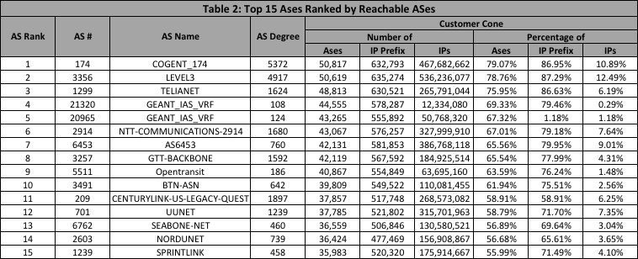

**Description:** The top 15 ranked ASes by the cutomer cone in percentage of IP addresses they can reach using provider to customer links.

